System Modernization BOK – Notes

Table of Contents

1 Why Legacy Modernization 2

1.1 Why is it strategic 2

1.2 Business Drivers 2

1.2.1 Changing business requirements 2

1.2.2 Increasing operations and maintenance costs 2

1.2.3 Incompatibility with modern technologies 2

1.3 Technology Challenges 2

1.3.1 Batch processing 2

1.3.2 Incompatible data standards 2

1.3.3 Lack of open APIs 2

1.3.4 Skills gap 2

1.4 Benefits 2

2 Leveraging APIS to Accelerate Legacy Modernization 2

2.1 API-led modernization Strategy 2

2.2 Common Challenges associated with modernization 2

2.3 Use Cases 2

2.3.1 Enabling legacy systems to consume external web APIs 2

2.3.2 Enable modern systems to consume data using APIs 2

# Why Legacy Modernization

## Why is it strategic

## Business Drivers

### Changing business requirements

### Increasing operations and maintenance costs

### Incompatibility with modern technologies

## Technology Challenges

### Batch processing

### Incompatible data standards

### Lack of open APIs

### Skills gap

### Technical debt

### Poor reuse

### Outdated DB models

### Batch/Point to Point interfaces

### Outdated UI

### Poor or no automated testing and CI/CD pipelines

## Benefits

Legacy modernization done correctly can:

* Free up IT delivery
* Enable new technologies
* Maintain Systems Integrity

# Leveraging APIS to Accelerate Legacy Modernization[1]

## API-led modernization Strategy

## Common Challenges associated with modernization

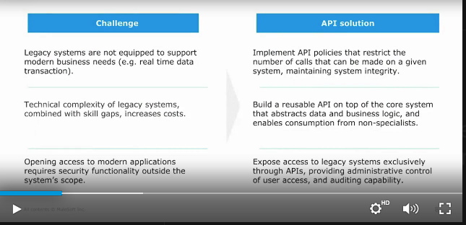

* Expose data thru an API (Access)
* Restrict and track API calls to data in legacy systems (Governance/Security)
* Abstract data and logic which enables consumption from non-specialists
* Control user access and auditing capability (Governance/Security)

## Use Cases

### Unlock data and logic

* Graphic legacy connector to REST API (mulesoft web transaction framework)
  + Data Queue

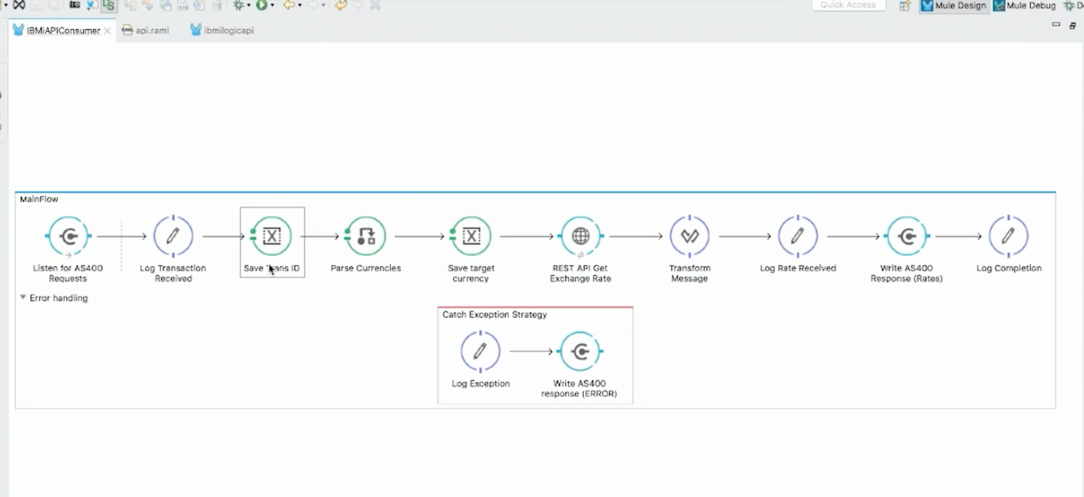

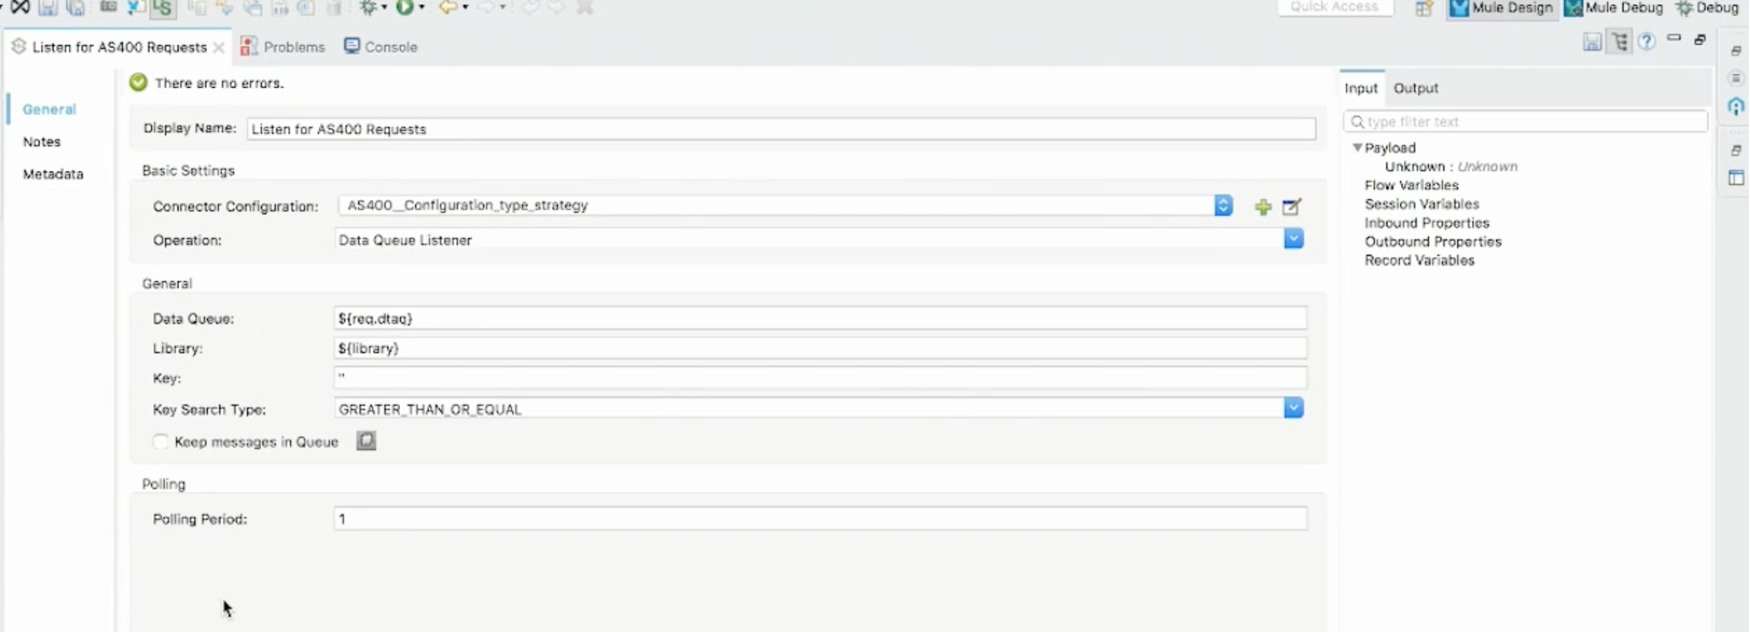

### Batch processes

### Enabling legacy systems to consume external web APIs

### Enable modern systems to consume data using APIs

#### Moving from batch mode to real-time interfaces

#### Data Security

##### Requires functions outside the original system scope

# Frameworks

## API Driven Development

# Techniques

## Reverse Engineer Use Documentation

## Reverse Engineer UI

# Artifacts

## Product Roadmap

### Strategy

* Strategy First

#### Business Model

A business model defines your framework for success. It is your unique DNA and what makes your approach to the market and serving customers special. Articulate your value proposition, key advantages, go-to-market plans, and more.

##### Lean Canvas

##### Segment Profile

##### SWOT

#### Strategic Vision

Vision explains the "why"

Vision defines your passion and soul. Dream big and define your view of the future.

##### Vision

##### Market

##### Mission

##### Strengths

##### Weaknesses

##### Personas

##### Competitors

##### Customer Challenges

##### Go to Market

##### Positioning

#### Goals

Goals are what you are aiming for. Set objectives so you can track your progress.

#### Initiatives

Initiatives are workstreams. Create the key themes your teams will be working on.

### Releases

## Ideas

## Features

1. https://www.mulesoft.com/ty/webinars/mainframe-to-microservices-legacy-modernization